**K&O**

**Personnel Management Systems**

**User Manual**

**FOUO**

# Table of Contents

# **1 Introduction4**

1.1 Who can benefit from a Personnel Management System4

1.2 Key Features4

2 Purpose4

3 Computer Requirements 5

3.1 Minimum PC Requirements5

3.2 Recommended PC Requirements5

3.3 Supported web browsers6

4 Security6

4.1 Secure Hash Algorithm6

4.2 Web Security6

5 Getting Started7-8

5.1 System Login7

5.2 System Options Login 8

6 User System9-16

6.1 User System Page9-10

6.2 Admin System Page11-13

6.3 Information 13

6.4 About 15

6.5 Connect with Us 17

7 Registration18-21

7.1 Admin Registration Screen 18

7.2 User Registration Screen 18

7.3 Accepted Registration 19-20

7.4 Registration Email 20

7.5 Activation Code 20

7.6 Authorization 21

8 System Login22-27

8.1 User Login 22

8.2 User Logout 24

8.3 Admin Login26

9 Admin Control28-38

9-1 Admin Navigation Panel28

9-2 Profile Page29

9-3 Task30

9-4 Admin Table31

9-5 Employee Table32

9-6 Worktable33

9-7 Time Worked Table34

9-8 Reset Locked Account35

9-9 Search Bar36

9-10 Alert Center36

9-11 Message Center37

9-12 Profile Menu37

9-13 Admin Logout38

10 Notes39

# 1 Introduction

Tracking and monitoring personnel in an organization is a strenuous and demanding task. The K&O Personnel Management System Application, combined a with secure and reliable online network and database system, the process of tracking individuals is easy and efficient.

# 1.1 Who can benefit from a Personnel Management System

* CEO of an organization
* Employers
* Managers
* Supervisors
* Employees

# 1.2 Key Features

* Friendly user interface that is easy to use.
* Generates unique ID number by use of a barcode generator.
* Includes a separate login screen for employees and administrators
* Separate interface for admin users to track and monitor employees
* The Admin interface includes well-designed built-in tables that track current employee status
* Runs on a secure web server that uses HTTPS over TLS protocol
* Life-time warranty with software support services included.

# 2 Purpose

Purpose: The primary purpose of the K&O Personnel Management System is to track the status of employees within an organization by use of a barcode ID system. User will be prompted to clock-in and clock-out by scanning or inputting their ID number followed by their personal pin number. Administrators will be able to track the current work status and hours of each employee assigned to the organization. This program is intended to be used by select administrators in a company. The program includes an admin suite

**RETURN**

# 3 Computer Requirements

# 3.1 Minimum PC Requirements

|  |  |  |  |
| --- | --- | --- | --- |
|  | **Windows Requirements** | **Mac Requirements** | **Linux Requirements** |
| **Operating System** | Windows 8 or later | OS X El Capitan 10.11 or later | 64-bit Ubuntu 14.04+, Debian 8+, openSUSE 13.3+, or Fedora Linux 24+ |
| **Processor** | Intel Pentium 4 or later that's SSE3 capable. | Intel | Intel Pentium 4 or later that's SSE3 capable. |
| **Memory** | 2 GB minimum | | |
| **Screen resolution** | 1280x800 or larger | | |
| **Application window size** | 280x653 or larger | | |
| **Internet connection** | Required | | |

# 3.2 Recommended PC Requirements

|  |  |  |  |
| --- | --- | --- | --- |
|  | **Windows Requirements** | **Mac Requirements** | **Linux Requirements** |
| **Operating System** | Windows 8 or later | macOS Sierra 10.12 or later | 64-bit Ubuntu 14.04+, Debian 8+, openSUSE 13.3+, or Fedora Linux 24+ |
| **Processor** | Intel Pentium 4 or later | Intel | Intel Pentium 4 or later |
| **Memory** | 4 GB or higher recommended | | |
| **Screen resolution** | 1280x1024 or larger | | |
| **Application window size** | 768x1024 or larger | | |
| **Internet connection** | Required | | |

**RETURN**

# 3.3 Supported web browsers

|  |  |  |
| --- | --- | --- |
|  | Version |  |
| Mozilla Firefox | Current 86.0(64bit) or higher |  |
| Chrome | Version 88.0.4324.190 (Official Build) (64-bit) current or higher |  |
| Microsoft Edge | Version 86.0.622.56 (Official build) (64-bit) current or higher |  |
| Safari |  |  |

# 4. Security

Security is top priority here at K&O Personnel Management Systems. Our system consists of multiple security protocols that are set in place to ensure user data is fully protected from potential threats. Though no system is 100% invulnerable against outside threats, we can assure you that our security protocol is top tier.

# 4.1 Secure Hash Algorithm

This program uses a SHA based algorithm to encrypt user data and protect against outsider threats.

# 4.2 Web Security

The web application is secured using HTTPS with transport layer security 1.2. A strict Content Security Policy is set in place to prevent Cross Site Scripting (XXS). The Domain Name System (DNS) is also secured with DNSSEC that adds additional cryptographic authentication.

**RETURN**

# 5. Getting Started

# 5.1 System Login

**System Screen**

The System Login Screen consist of a single login form only and navigation bar. Only selected administrators can login to the main System. All other users are not authorized and will be denied access.

1. Selected admins will be required to scan their ID or manually enter in their ID number.

2. You must enter in your 4-10 pin# correctly. You will only have three attempts to login. Failure to enter in your pin# correctly will result in a temporary block of access on your account.

3. Buttons:

3a. K&O Button: Refreshes/ returns to the System Login Screen.

3b. User Portal Button: Redirects to the System Options Login Page. Click the link or go to page 8 of the user manual (link).

**RETURN**

# 5.2 System Options Login

**User System/Admin System Login**

The System Options Screen consist of a two single login forms. Only selected administrators can login to the either System. All basic users are not authorized and are denied access. Refer to the User login page for basic user logins.

1. Selected admins will be required to scan their ID or manually enter in their ID number.

2. You must enter in your 4-10 pin# correctly. You will only have three attempts to login. Failure to enter in your pin# correctly will result in a temporary block of access on your account.

**RETURN**

# 6 User System

# 6.1 User System Page

Footer Links

Navigation Panel

Login Form

**System User Page**

**RETURN**

The System User Page screen consist of a navigation bar with links, display body, and footer with links.

Navigation Bar

1. Navigation Buttons

* K&O Home Button
* Access Menu
* Create Account Menu
* Portal Logout

1a. K&O: Redirects to Home page

1b. Access Menu

* Clock-in- Redirects to user Login Page (Link)
* Clock-Out- Redirects to user Log Out Page (Link)

1c. Portal Logout

* Redirects to **User System/Admin System Login.** (Link)

**Footer**

1. Footer Links

* Connect with Us
  + Facebook
  + Twitter
  + Google Plus
  + YouTube

**RETURN**

# 6.2 Admin System Page

Footer

Main Body

Navigation bar

**Admin Screen**

The Admin screen consist of a navigation bar with links, display body, and footer with links.

**RETURN**

Navigation Bar

1. Navigation Buttons

* K&O Home Button
* Access Menu
* Create Account Menu
* Info Menu
* Admin Portal
* System Logout

1a. K&O: Redirects to current page

1b. Access Menu

* Admin Portal- Redirects to Admin Login Page (Link)
* Clock-in- Redirects to user Login Page (Link)
* Clock-Out- Redirects to user Log Out Page (Link)

1c. Create Account Menu

* Create Admin Account- Redirects to Admin Registration Page. (Link)
* Create User Account- Redirects to User Registration Page (Link)

1d. Info

* About - Redirects to “About Company” Page. (Link )
* Mission- Redirects to “Company Mission” Page ( Link)
* Contact- Redirects to “Company Contact” Page

1e. Admin Portal

* Displays Admin Login form(Link)

1f. System Logout

* Redirects to System Login Page. (Link)

**Footer**

1. Footer Buttons

* About
  + A. Company
  + B. Team
  + C. Careers
* Help
  + A. K&O Menu (Downloadable Document)
  + B. Team
  + C. Careers

**RETURN**

* Connect With Us
  + Facebook
  + Twitter
  + Google Plus
  + YouTube

1b. About

* Company- Redirects to company information page (Link)
* Team- Redirects to company team page(Link)
* Careers- Redirects to company careers page (Link)

# 6.3 Information

Figure 5-4

1. Information Drop Down Menu

1a. About: Displays information of what the company is about. “K&O Personnel Management System is a web-based application that uses a database to access and store user data, so organizations can better track and monitor their employees”.

1b. Mission: Displays the company’s mission and vision.

**Figure 5-5 Figure 5-6**

# Vision

“Efficient and reliable tracking system for all organizations big or small”.

# Mission

To create a secure and reliable personnel management system for all organizations worldwide.

1c. Contact: The contact page contains the companies phone roster per section. This includes the company leadership, admin, security, operations, human resource, and finance section.

**RETURN**

# 6.4 About

Figure 5-8

**1. Company (****Link****)**

**1a.** Display’s information about the company.

**2. Team (****Link****)**

**2a.** Displays company CEO’s

**3. Careers (****Link****)**

**3a.** Redirects to the company career page where the user can view company career opportunities.

# Figure 5-9

**1. Company**

1a. The company link redirects to a page that displays information about the company.

**RETURN**

# Figure 5-10

**2. Team**

**2a.** The team link redirects the user to a page that displays the current company page.

# Figure 5-11

**3. Company Careers (Link)**

**3a.** The company career page displays different employment opportunities and methods to contact the company. The user may contact the company by sending a brief message about their concerns.

**RETURN**

**3b.** Current Job Positions: List the current available jobs for the company.

**3c. Student Opportunities:** Displays current opportunities for recent graduates and current students.

# 

**RETURN**

# 6.5 Connect with Us

**1. Social Media Links**

**1a.** Connect with us via Facebook, Twitter, Google Plus, and YouTube on up-to-date technological advancements.

Figure 5-10

**RETURN**

# 7. Admin/User Registration

# 7-1 Admin Registration Screen

000000000000

# 7-2 User Registration Screen

000000000000

**Registering for an Admin/User Account**

**RETURN**

**1.** Select the create account tab from the navigation and select the create admin/user account link.

**2. Input Data**

2a. If you are registering for an Administrative account, you will be required to fill out every block on the form as accurate as possible. If the information you input is not accurate, you will be restricted from the system until an administrator reviews your form. Access will be granted once your data is verified and clear.

**3. Create Pin**

3a. You will be required to create a 4–10-digit pin number that will be used to log you in and out of the system.

3b. You will be required to re-enter the 4–10-digit pin number. For the form to process correctly, you must ensure both pin numbers match. If they do not match, an error page will be display and you will be redirected to the registration page.

**4. Unique ID**

4a. All Admins and Basic Users will be given an auto-generated unique identification number. This number will be encoded in the barcode and is required to gain access to the system.

# 7-3 Accepted Registration

Print Button

**RETURN**

**Accepted Registration**

**1. Print Barcode**

**1a.** Select the print button and print the document. You have the option to either print or save the document to a PDF. *Note: You will not be able to return to the barcode print page after selecting the home button. Ensure you retain a copy of your access barcode before leaving the barcode print page.

# 7-4 Registration Email

Activation Link

Activation Code

**1. Email Verification**

**1a.** Users will receive an email confirming their registration. A number code will be included in the email and is used as a first-time login activation code. The user will be prompted to click on the link included email. The user will be redirected to an activation page (**figure 7-5**) Once the user inputs the code their account will be fully activated.

**2. Activation Code**

# 7-5 Activation Code

**RETURN**

**2a.** The user will be prompted to input the activation code. If the user enters the activation code correctly, a page will display “Authorization Success” **(****figure 7-6****).** Click done when complete and you will be redirected to the main system login page.

# 7-6 Authorization

**2b.** If the user incorrectly enters the activation code, an “Authorization Failed” page will be displayed and the user will be redirected back to the activate account page to try again. If the user has trouble inputting the correct activation code or there is an issue with the code, please contact an administrator to resolve the problem.

**RETURN**

# 8 System Login

# 8-1 User Login

**1. Clock-In:** Click on the Access tab to access the dropdown menu. Click on the Clock-In link.

# Figure 8-2

Access Pin Number

Unique ID Number

**2. Login Credentials**: Scan or manually enter in your Unique Identification number. Enter you secretly created pin number.

Note: If you enter your pin number incorrectly three times you will be locked out from the system. You will be directed to the Administrator to reset your pin number.

**RETURN**

# Figure 8-3

**3. Login Success**: If you entered in your credentials correctly, “Login Success” is display, and you will be logged into the system.

# Figure 8-4

**4. Login Failed:** If you failed to enter in your credentials correctly, you will be redirected to a 404 page.

**RETURN**

# 8-2 User Logout

**1. Clock-Out:** Click on the Access tab to access the dropdown menu. Click on the Clock-Out link.

# Figure 8-2

Unique ID Number

Access Pin Number

**2. Logout Credentials**: Scan or manually enter in your Unique Identification number. Enter you secretly created pin number.

Note: If you enter your pin number incorrectly three times you will be locked out from the system. You will be directed to the Administrator to reset your pin number.

# Figure 8-5

**3. Logout Success**: If you entered in your credentials correctly, “Logout Success” will be displayed, and you will be logged out of the system.

**RETURN**

**4. Login Failed:** If you failed to enter in your credentials correctly, you will be redirected to a 404 page. Refer to Fig. 8-4 (**Link**).

**RETURN**

# 8-3 Admin Login

# Figure 8-6

**1. Admin Login:** Click on the Admin Portal tab on the navigation bar and a popup login form will appear. You also can click on the Access tab and click on the Admin login link. A popup login form will appear.

**RETURN**

# Figure 8-7 Admin Login Form

**2. Login Credentials**: Scan or manually enter in your Unique Identification number. Enter you secretly created pin number.

Note: If you enter your pin number incorrectly three times you will be locked out from the system. You will be directed to the Administrator to reset your pin number.

**4. Login Failed:** If you failed to enter in your credentials correctly, you will be redirected to a 404 page. (Ref Link)

**RETURN**

# 9 Admin Control

**1i**

**1h**

**1g**

**1f**

**1e**

**1d**

**1c**

**1b**

**1a**

**2d**

**2c**

**1b**

**2a**

Navigation Bar

Main Dashboard

Navigation Panel

# 9-1 Admin Control Navigation Panel

**1. Navigation Panel**

**1a. Dashboard**

**1b. Profile**

**1c. Task**

**1d. Admin Table**

**1e. Employee Table**

**1f. Work-Table**

**1g. Time Worked Table**

**1h. Reset Locked Account**

**1i. Logout**

**RETURN**

# 9-2 Profile Page

1d

1b

1a

1c

**1. Profile**

**1a. Photo**

**1b. User Settings**

* **Username**
* **First Name**
* **Last Name**
* **Email Address**

**1c. Projects**

**1d. Contact Settings**

* **Address**
* **City**
* **Country**

**RETURN**

# Figure 9-3 Task

Add Button

Delete Button

**1. Admin to Do List:**

**1a. Purpose:** The purpose of the task table is to allow the administrator to input upcoming events and have the option to delete them when complete. Max character limit per event is 100.

**1b. Add Task:** To add a task, the user will type his/her task in the input box (not to exceed 100 char) and click the add button control.

**1c. Delete Task:** To delete a task, the user will click on the delete button next to the task he/she wishes to delete.

**RETURN**

# 9-4 Admin Table

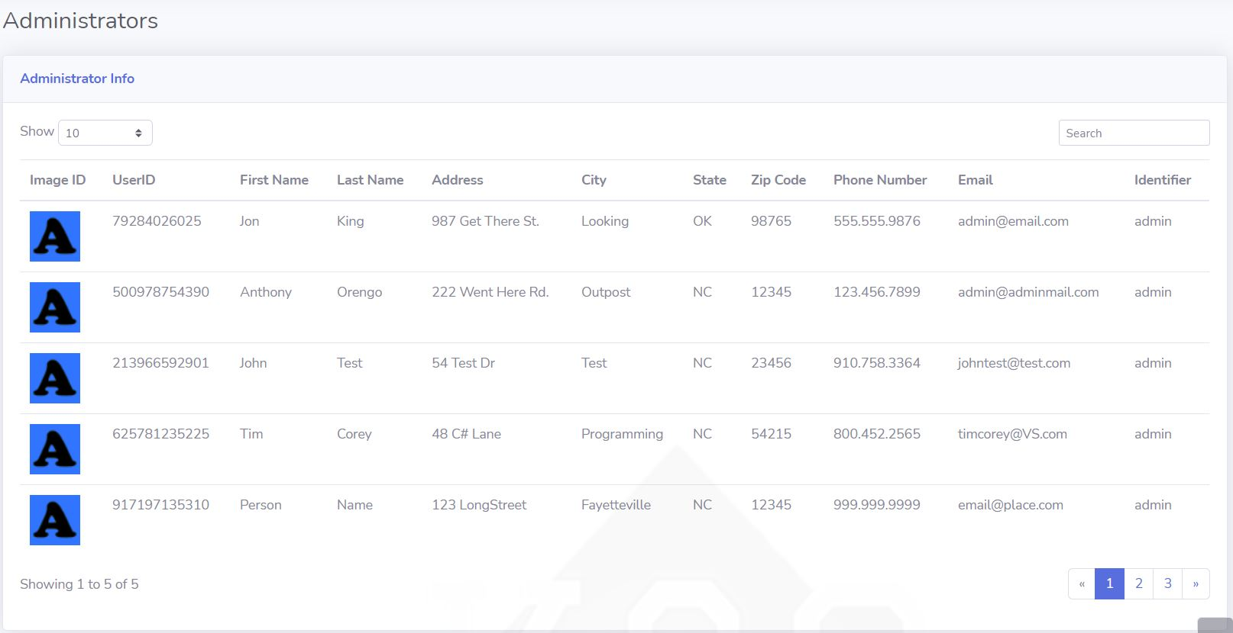

**1. Administrator Table:**

**1a.** The admin table consist of all current administrators who have been granted access to the K&O System. Information on each administrator can be found here minus the access pin (**Refer to 1b below**). The admin table serves as a quick method to obtain data on a specific administrator (mailing address, phone number, etc.).

**1b.** Access pins are regulated by database managers who have been granted access to alter or change the database table.

**RETURN**

# 9-5 Employee Table

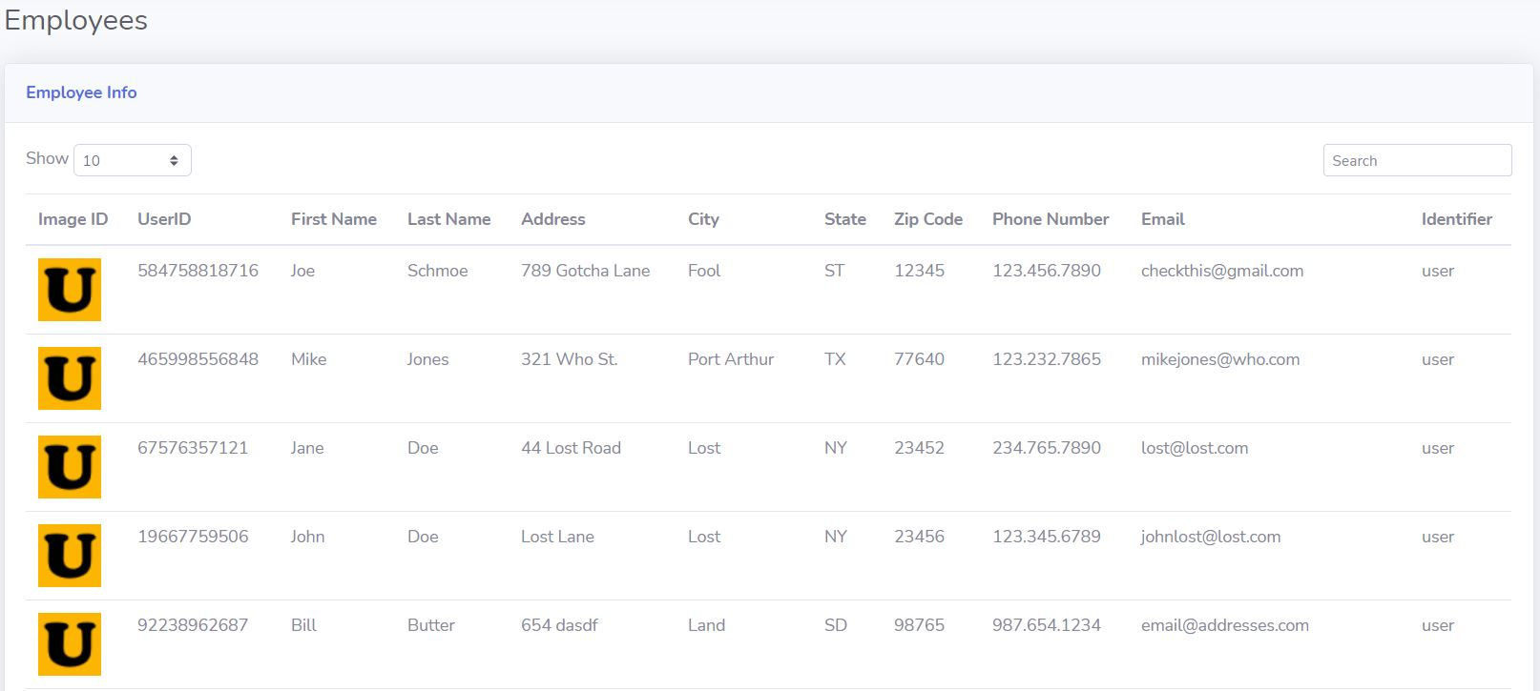

**1. Administrator Table:**

**1a.** The employee table consist of all current employees who work at the organization. Information on each employee can be found here minus the access pin (**Refer to 1b below**). The employee table serves as a quick method to obtain data on a specific employee (mailing address, phone number, etc.).

**1b.** Access pins are regulated by database managers who have been granted access to alter or change the database table.

**RETURN**

# 9-6 Worktable

# 

**Shift Tracker Table:**

**1a.** The shift tracker table consist of all current users(admins excluded) who are currently logged in to the K&O System. Login and logout times can be found here along with the total time and status (in/out).

**RETURN**

# 9-7 Time Worked Table

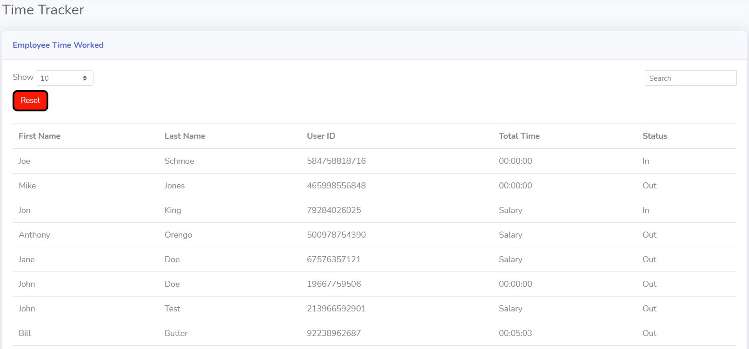

**Time Tracker Table:**

**1a.** The time tracker table consist of all current users to include admins who currently work at the organization.

The table displays the users and admins total time worked. This can be used to calculate payroll or other means that seem fit by your organization.

**RETURN**

# 9-8 Reset Locked Account

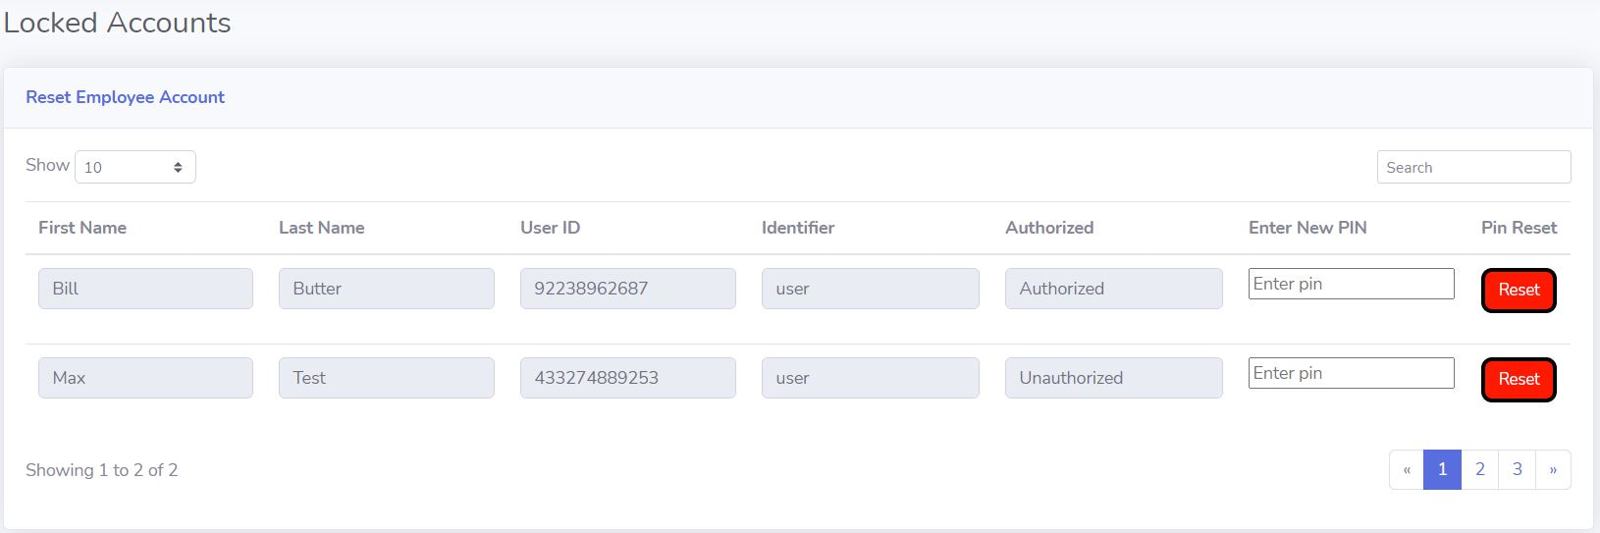

**Reset Locked Account:**

**1.** The Reset Locked Account page gives the administrator the option to unlock a user’s account in the event the user is locked out of their account.

**1a.** Verify User: The administrator must verify the user prior to resetting the pin.

**1b.** Enter New Pin: Prompt the user to enter in their new 4-10 digit pin. Click the reset button to replace the old pin with the new pin.

**RETURN**

**2. Navigation Bar**

**2a. Search bar**

**2b. Alert Center**

**2c. Message center**

**2d. Profile Menu**

# Figure 9-9 Search Bar

**Admin Search Bar**

**1.Search Bar**

**1a.** The administrator can use the search bar to find a specific location or tool within the admin control page. If the element you are looking for is not located within the admin control panel, you will be prompted with an error message.

# 9-10 Alert Center

**1.Alert Center**

**1a.** The administrator can use the Alert Icon to view incoming alert messages from the system or organization. Just simply click the icon to view current alert messages. Note: Only important messages will be directed through this channel.

**RETURN**

# 9-11 Message Center

**1. Message Center**

**1a.** The administrator can use the message Icon to view incoming messages from the system or organization. Just simply click the icon to view current messages. Note: Only basic messages will be directed through this channel.

# 9-12 Profile Menu

**1.Profile Dropdown Menu**

**1a.** The administrator can use the profile dropdown menu to quickly access other sections of the admin control panel. You have the option to view your profile, settings, activity log, and logout.

**RETURN**

# 9-13 Admin Logout

**1. Admin Logout**

**1a**. Logout: To logout of the admin control page, simply click the logout link to end the admin session. You also have the option to use the logout link in the profile dropdown menu.

**RETURN**

# 10 Notes

**Notes**

**______________________________________________________________________________________________________________________________________________________________________________________________________________________________________________________________________________________________________________________________________________________________________________________________________________________________________________________________________________________________________________________________________________________________________________________________________________________________________________________________________________________________________________________________________________________________________________________________________________________________________________________________________________________________________________________________________________________**

**______________________________________________________________________________________________________________________________________________________________________________________________________________________________________________________________________________________________________________________________________________________________________________________________________________________________________________________________________________________________________________________________________________________________________________________________________________________________________________________________________________________________________________________________________________________________________________________________________________________________________________________________________________________________________________________________________________________**

**RETURN**

**______________________________________________________________________________________________________________________________________________________________________________________________________________________________________________________________________________________________________________________________________________________________________________________________________________________________________________________________________________________________________________________________________________________________________________________________________________________________________________________________________________________________________________________________**

**RETURN**

**This Page Left Blank Intentionally**

**This Page Left Blank Intentionally**

 © 2021 KandOPersonnelManagementSystems.com | Designed by Jon King/Anthony Orengo

**RETURN**